**Impact Report**

**April 26, 2022**

**Prepared by: Alethia O’Hara-Stephenson**

Table of Contents

About DCCBA 4

OCWA Support Specific Impacts: 5

Scholarship Program 5

**Year 2021 Scholarship Winner** 5

**Year 2021 Scholarship Winner** 6

DCCBA Overall Community Impacts 6

Cultural Education: 7

Marketing 7

Testimonials: 8

Bursary Program 8

Financial Literacy: 8

High Level Stats 8

Dufferin County Canadian Black Association (DCCBA)

718 Halbert Drive,

Shelburne ON, L9V 2S5

April 18, 2022

Ontario Clean Water Agency

2085 Hurontario Street

5th Floor, Mississauga, ON L5A 4C1

Dear Natalie,

Thank you for generously supporting the Dufferin County Canadian Black Association in 2021. We are delighted to share with you that we have had an incredible 2021 with so many accomplishments and barriers broken. Thanks to your generous support we were able to offer two students’ scholarship in the name of Ontario Clean Water Agency. All the students who applied were amazing which made it very difficult to select just two. Please find in the package below, a brief bio and picture on both students who were the recipients of the 2021 Ontario Clean Water Agency Science Scholarship.

We have also shared with you our overall impact statement highlighting all our accomplishments for 2021. We hope you take the time to review the details provided and feel proud that you have impacted the lives of not just 2 students but hundreds of other families in Dufferin County through the work that we are doing.

As we are getting ready to ramp up our 2022 Scholarship program, we are hoping we can count on your support again for 2022 and beyond.

Thank you once again for your support and we look forward to hearing from you again soon.

Regards,

*Alethia O’Hara-Stephenson*

Alethia O’Hara-Stephenson CIP,BA,MBA

President & Founder, Dufferin County Canadian Black Association

[www.dufferincountycba.org](http://www.dufferincountycba.org)

# About DCCBA

The Dufferin County Canadian Black Association was founded on June 3, 2020 by Shelburne resident Alethia O’Hara Stephenson. The impetus for the creation of the Association followed after many discussions with community members, political leaders and stakeholders about the growing Black population in Dufferin County (Blacks including those of African decedent and individuals from the Caribbean and Latin diaspora) and the need to provide a voice, advocacy, a safe space along with educational programs, support services, community outreach and scholarship opportunities benefiting families and businesses within Dufferin County.

The (DCCBA) is committed to being a true community partner working with other established agencies to bring value to the Dufferin County community. Our Association is inclusive and welcoming to all who wish to volunteer, provide feedback, attend events and sign up for future programs.

***Mission:*** *To provide leadership for the continued development and enhancement of the Black community through civic engagement, education, programs and services and advocate for equity and wellbeing for the Black community in Dufferin County. To be a central hub for resources, tools and programs that are unique to the needs of the Black Community in Dufferin County*

***Vision:*** *To develop and foster a socially and economically equitable group that will continue to contribute to the growth and development in Dufferin County and Canada. To have a strong focus on Youth Achievement and Excellence. To partner with government officials (all levels), local businesses & community organizations to better serve the community.*

***Values:***

* EDUCATION - We promote education as the primary vehicle to economic mobility and sustainability for our community.
* INTEGRITY - We lead with integrity in all aspects of our work - demonstrating honesty and moral change.
* EXCELLENCE - We expect and deliver the very best whenever representatives of the DCCBA are involved.
* ADVOCACY - We take active and measurable steps to influence decisions within political, economic, and social institutions.
* DIVERSITY & INCLUSION - We serve as a champion for and live out diversity and inclusion at all times.
* TRANSPARENCY - We stay accountable to members of the community.
* COLLABORATION - We recognize that the path toward equity requires working together with all community partners.

# OCWA Support Specific Impacts:

## Scholarship Program

In 2021 DCCBA was proud to award 2 amazing black students with the OCWA scholarship. We had 5 applicants in total for this category.

Each student received a certificate with the OCWA Name as the sponsor as well as letters from our MP, MPP and Mayor for the Town of Shelburne acknowledging each recipient for their award again naming the scholarship sponsor.

The scholarship award ceremony was captured by local reporters and highlighted in the Toronto Star. See link for details: [Students land scholarships at DCCBA award ceremony | The Star](https://www.thestar.com/news/canada/2021/08/05/students-land-scholarships-at-dccba-award-ceremony.html)

A profile of each student can be found on our website [here](https://dufferincountycba.org/scholarship_winners?page=2&entry=10).

**Student Profile 1: Precious Adesina**

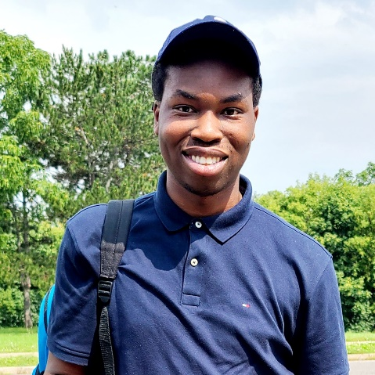

### **Year 2021 Scholarship Winner**

Bio: Precious Adesina is a 3rd year student at York University. With an ‘interest in studying environmental disasters such as earthquakes and hurricanes and he is very fascinated with reading about how these disasters are formed and how science plays a major role

**Student Profile 2: Graden Grandison**

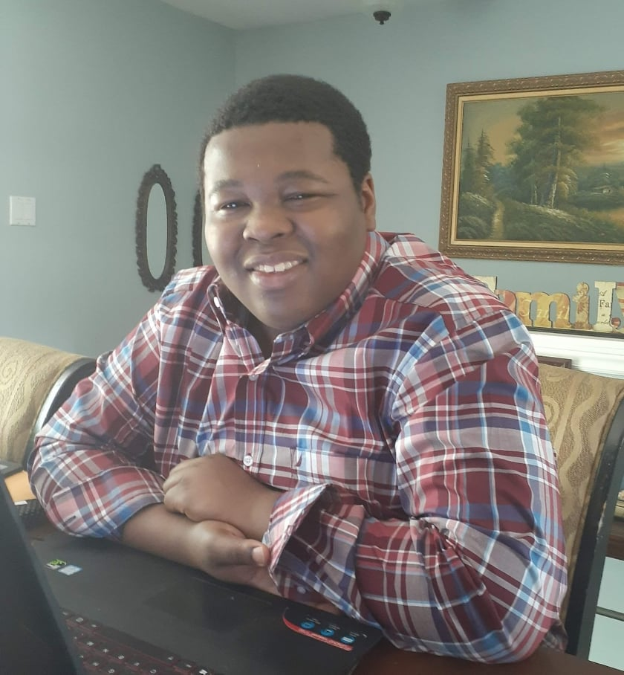

### **Year 2021 Scholarship Winner**

Bio: Graden Grandison is going into his 2nd year in the University of Guelph’s Biomedical Science Program with a place on the Dean’s list.  
Graden is an avid volunteer both in the school and community. He is 1 of 3 nominees for valedictorian and was the salutatorian for his graduating class at Robert F. Hall.  
Graden plans to become a doctor in the future

# DCCBA Overall Community Impacts

Despite the limitations of the COVID 19 Pandemic, we have had tremendous success with our programs, and we could not have done it without the support of our community partners, volunteers, and sponsors.

In 2021 we were able to award scholarships to 11 students from Dufferin County and surrounding area. We awarded 3 elementary school students in Dufferin County with bursaries.

First Annual Scholarship Award Ceremony held in August 2021 with tremendous success and feedback from participants, scholarship recipients and sponsors.

We championed several initiatives during the year such as Vaccine Information Session in partnership with WDG Public Health. We exhibited strong and timely advocacy on the behalf of the Black community. Most notably, our intervention with the UGDSB to remove harmful reading materials after a complaint was brought by a student and her family to DCCBA. As a result of our involvement, not only were we able to get the reading material removed but also received assurances from the UGDSB that measures would be immediately put in place to ensure that this occurrence would never happen again.

DCCBA has held several successful Ask the Experts Sessions (one each month from January 2021 to present). Based on the feedback, the sessions have added tremendous value to members of our community.

We continue to be leaders and change makers in the space of Diversity, Equity, and Inclusion. We are proud to be an organization that is highly sought after to participate in conferences, business engagements and requests for training sessions.

With respect to our commitment to expose Black youths in Dufferin County to meaningful learning opportunities, DCCBA was excited to offer 4 students a spot in the popular Coding program hosted by a local organization.

In addition to the Coding program, DCCBA was also able to register 8 students of diverse backgrounds in Dufferin-County for an online Toastmasters program.

## Cultural Education:

Part of DCCBA’s mandate is to provide inspirational and cultural exposure to the community we serve. With a particular emphasis on local leaders that are influential when it comes their advocacy on Diversity, Equity, and Inclusion. In 2021, DCCBA was proud to secure 15 copies of Shelburne Deputy Mayor’s inspirational book, Driven to Succeed. The book is a powerful example of overcoming adversities and persevering to achieve success.

In addition, DCCBA proudly sponsored 3 Youth from the community allowing them to learn and participate in the sport of Cricket. This popular sport around the world has grown quickly in the Town of Shelburne. While the game is entertaining, it also provides an opportunity for youth mentorship and bonding with the older players. Without the support of DCCBA, these youths would not have the opportunity to play and benefit from being around positive role models.

DCCBA also allocated funding for the Black History Month event in 2021- enabling us to provide culturally relevant information that was streamed live on YouTube. This hugely successful event drew a diverse audience from across Dufferin County and surrounding Areas.

DCCBA was also excited to partner with Streams Community Hub to support art in Dufferin County.

Lastly, with the goal of facilitating cultural learning opportunities and ongoing outreach with the community, DCCBA purchased 4 tablets and 1 laptop for onboarding volunteers and management to use. This has become particularly important in midst of a global pandemic where in-person connections have largely been curtailed at the advice of Public Health.

Marketing:

DCCBA teamed with Welcome to Shelburne to provide marketing materials about the organization for the benefit of new residents. Our marketing items were sourced from an organization in Dufferin County.

As part of our marketing budget a removable & reusable plaque with a QR Code was sourced from a business in Dufferin County and placed in the widely used Shelburne Community Garden.

In 2021, DCCB became a title sponsor for the Shelburne Cricket Club. DCCBA’s logo is now used on all uniforms, print marketing, social media and on trophies. With the sport of cricket growing rapidly in the Town of Shelburne, this was seen as supportive and good marketing for DCCBA.

# Testimonials:

Bursary Program  
“Recognizing our students in the elementary schools is critical to their future success and I’m so happy that your organization is providing this opportunity for them as they are often excluded”. JB, Teacher

## Financial Literacy:

“Super informative”! JS

“Will we be getting a copy- This is amazing”! AO

“Very Helpful”! SC

“Very informative, clearing lots of concepts. Thank you”! KM

“Truly well presented”! SL

“Great event, lot of information...very well presented”! KM

“Great info. Thanks to all”. SL

"It was great information" SL

"Thank you. This was enlightening." RS

"Thank you, Kamran! Very informative" JS

"Thanks Kamran" SL

"A lot in our community need this info. Hopefully they make the connection with the speaker and get the coverage. AC

"Thank you so much for this session, content and delivery was awesome" PFG

# High Level Stats

100% of surveyed participants found value in the programs and events that DCCBA has organized

100% of surveyed participants said they would register for another program

**During the period February to November, we have received:**

6 requests from families for support

2 Requests from schools seeking support for students

5 requests for additional programs and events.

**Closing comments**

As the organization continues to grow, we will rely heavily on support from community grants, government grants and sponsors to be able to continue to provide valuable programs and services to the community.

* END -